**Experiment No. 3.1**

**Student Name: Rishav Kumar UID: 22MCC20039**

**Branch: MCA - CCD Section/Group: MCD-1/ Grp A**

**Semester: III Date of Performance: 24th Oct 23**

**Subject Name: Business Analytics Subject Code: 22CAH-703**

1. **Aim/Overview of the practical:**

Installation of Tableau

**2. Code for practical:**

Tableau is a popular data visualization tool that allows you to connect to various data sources and create interactive and insightful visualizations. To install Tableau Desktop, follow these general steps:

* **Download Tableau Desktop:** Go to the official Tableau website to download Tableau Desktop. Tableau offers a free trial version, so you can explore its features before purchasing a license.
* **Run the Installer:** Once the Tableau Desktop installer is downloaded, run the installer by double-clicking on the downloaded file.

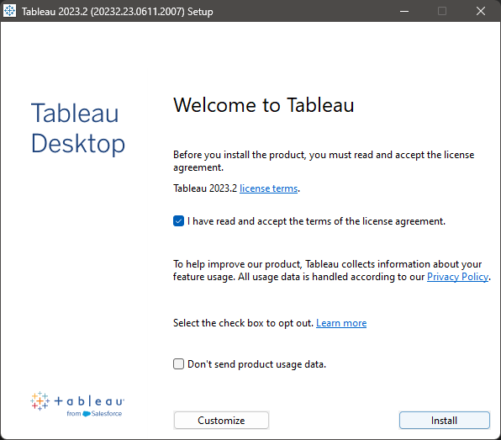

* **Accept the License Agreement:** Review and accept the Tableau Desktop license agreement.
* **Choose Installation Type:** You will be prompted to select the installation type. Choose "Tableau Desktop."
* **Select Installation Location:** Choose the directory where you want to install Tableau Desktop.
* **Configure Your Preferences:** Set up your preferences, such as the Start Menu folder, and whether you want to create shortcuts on your desktop.

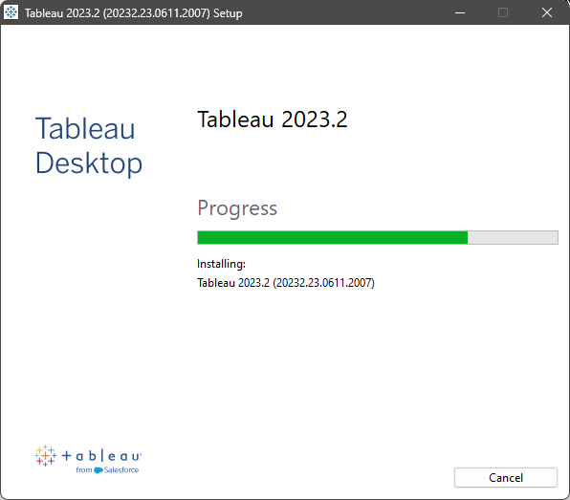

* **Provide User Information:** You may be asked to provide user information, such as your name and organization. Fill in this information as needed.
* **Activate Your License:** If you are using a trial version, you will need to provide your email address to activate your trial license. If you have a purchased license, you will need to enter the product key during installation.
* **Complete the Installation:** Once you've configured all the settings, click "Install" to begin the installation process.
* **Finish the Installation:** Wait for the installation process to complete. When finished, you will see a confirmation message.
* **Launch Tableau Desktop:** You can now launch Tableau Desktop. It will prompt you to sign in or provide your license information.

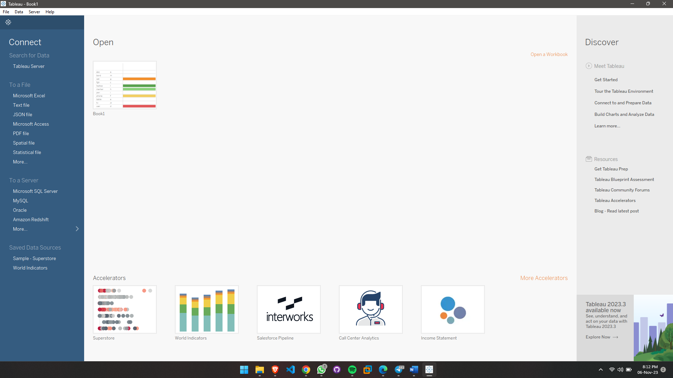

* **Sign In or Activate:** If you have a Tableau account, sign in. If you are using a trial or have a product key, you may need to activate the software at this point.
* **Start Using Tableau:** Once you've signed in or activated Tableau, you can start using Tableau Desktop to connect to data sources, create visualizations, and perform data analysis.

**************************************** **THE END** ***********************************************